W2D1 Homework

1 What’s character of these Collection, List, Set and Map? ArrayList and LinkedList? HashMap and TreeMap?

Collection - the root interface for Collection. Defines methods that holds other Objects.

Collections - Utility Class that contains static methods that do certain operations related to Collection.

List - an Interface Ordered collection that allows duplicate elements.

Set - an Interface Unordered collection that doesn't allow duplicate elements.

Map - an Interface that stores key and value in pairs. May have duplicate values but not duplicate keys.

ArrayList - is a dynamically resizing array

LinkedList - elements are linked together

HashMap - order of the keys can be sorted but can not be sure that it will remain in order

TreeMap - order of the keys can be sorted and you can expect that they will be in order.

2. （List）Read the codes

**import java.util.*;**

**public class Test {**

**public static void main(String args[]) {**

**List list = new ArrayList();**

**list.add("Hello");**

**list.add("World");**

**list.add(1, "Learn");**

**list.add(1, "Java");**

**printList(list);**

**}**

**public static void printList(List list) {**

**// 1**

**for (int i = 0; i < list.size(); i++) {**

**System.out.println(list.get(i));**

**}**

**for (Object o : list) {**

**System.out.println(o);**

**}**

**Iterator itor = list.iterator();**

**while (itor.hasNext()) {**

**System.out.println(itor.next());**

**}**

**}**

**}**

Requirement:

1. Complete the codes at //1, and need to print out all the elements of the list.
2. Write the output of the code.

Hello

Java

Learn

World

Hello

Java

Learn

World

Hello

Java

Learn

World

1. Where and how to modify if change Arraylist with LinkedList? What’s the difference between ArrayList and LinkedList?

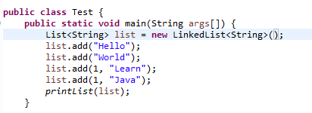

In a LinkedList, each element is linked to its previous and next element making it easier to delete or insert in the middle of the list. An ArrayList is more as its name subjects used as an array.

1. Where and how to modify if change Arraylist with Vector? What’s the difference between ArrayList and Vector?

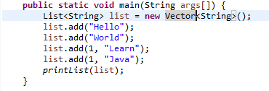

Vectors are synchronized, ArrayLists are not.

3. （List）Write the output of the program.

**import** java.util.*;

**public** **class** TestList {

**public** **static** **void** main(String args[]) {

List list = **new** ArrayList();

list.add("Hello");

list.add("World");

list.add("Hello");

list.add("Learn");

list.remove("Hello");

list.remove(0);

**for**(**int** i = 0; i < list.size(); i++) {

System.***out***.println(list.get(i));

}

}

}

ANSWER:

Hello

Learn

4. Select the right one?

**import** java.util.*;

**public** **class** TestListSet {

**public** **static** **void** main(String args[]) {

List list = **new** ArrayList();

list.add("Hello");

list.add("Learn");

list.add("Hello");

list.add("Welcome");

Set set = **new** HashSet();

set.addAll(list);

System.***out***.println(set.size());

}

}

1. Compile with error
2. Compile correctly, but throw exception when running.
3. Compile and run well, and output 3
4. Compile and run well, and output 4

ANSWER: 3

5 (List, Map)

**public** **class** Worker {

**private** **int** age;

**private** String name;

**private** **double** salary;

**public** Worker() {

}

**public** Worker (String name, **int** age, **double** salary) {

**this**.name = name;

**this**.age = age;

**this**.salary = salary;

}

**public** **int** getAge() {

**return** age;

}

**public** **void** setAge(**int** age) {

**this**.age = age;

}

**public** String getName() {

**return** name;

}

**public** **void** setName(String name) {

**this**.name = name;

}

**public** **double** getSalary() {

**return** salary;

}

**public** **void** setSalary(**double** salary) {

**this**.salary = salary;

}

**public** **void** work() {

System.***out***.println(name + "is working");

}

}

Please finish the requirement:

1. To create a List and add three workers, and their information shown like this:

|  |  |  |
| --- | --- | --- |
| Name | Age | Salary |
| Simon | 20 | 10000 |
| Jame | 25 | 13000 |
| Alex | 22 | 12000 |
|  |  |  |

1. Add one worker before Jame ( Steven, 24, 15000)



1. Remove the worker Alex’s information



1. Go through the list using for statement and print out all the worker’s information.

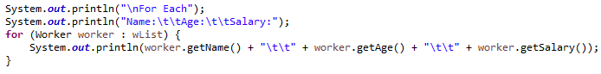

1. Go through the list using Iterator statement to call all the worker’s method work.

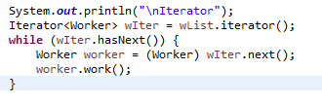

1. Over write the equals method for the class Worker. New equals method return true only if the workers’ name, age and salary are the same at the same time.

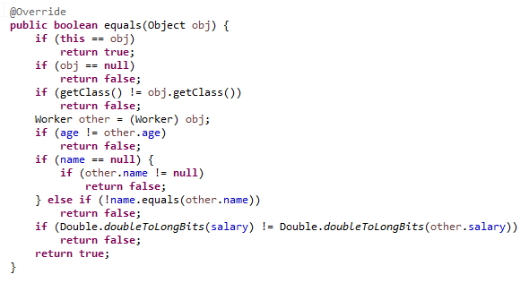

1. **Sort the all the workers from high to low by salary** and print out the all the workers information with the format “Name: “ + name + “ Salary: “ + salary.

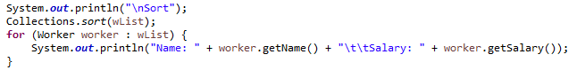

1. Add a id to Worker class, and save the above data to workMap. Map<String, Worker > ( Worker ID, Worker) . **At least three ways t**o go through the workMap, to print out all the workder’s information with Worker id and all other information like “Worker Id: “ + “Name: “ + name + “Age: “ + age + “ Salary: “ + salary.

